Anne-Lise Gere, SPHR
Speaker Biography
Anne-Lise Gere, SPHR works with home care agencies across the country. She provides HR guidance and works on creating strong HR systems with franchise owners and independent agencies. She also specializes in caregiver recruitment and retention strategies for agencies of all sizes.
She writes weekly blogs on HR in Home Care, employment compliance and employee relations for small and growing businesses. The blogs can be found at www.GereConsulting.com/blog.
Anne-Lise is a regular key note speaker at conferences across the country addressing HR matters relevant to home health. Her on-stage speaking credits include:
- National Private Duty Conference (November 2016, Las Vegas),
- ElevatingHome National Leadership Conference (March 2018, Washington DC),
- Home Care Association of Florida (January 2018),
- Home Care Providers of NYS (October 2018)
- Home Care Association of Nebraska (January 2019).
- New England Association of Hospice and Home Care (June 2019)
- Six presentations at the Hurricane Marketing Boot Camps with Steve “The Hurricane” Weiss (2016-2019) the most recent at the Caregiver Summit in November 2019.
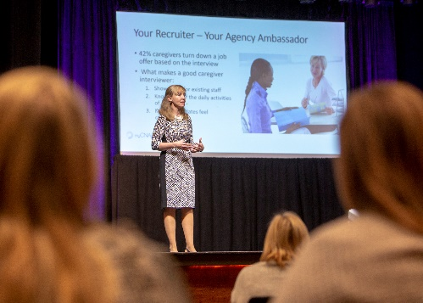
In addition to on-stage presentations, Anne-Lise is a frequent guest of webinars where she shares her expertise with a wide audience in senior care and with fellow HR professionals.
Before working as an independent HR consultant and advisor, Anne-Lise worked in HR at Siemens Automotive, and Procter & Gamble in both Europe and the US. She holds a Master’s degree in Management from Cambridge University, England. She is a certified Senior Professional in Human Resources with the HR Certification Institute (HRCI).
Anne-Lise is a committed HR professional. Since 2010, she serves as a subject matter expert with HR Certification Institute where she contributes to exam development for the SPHR, aPHR, SPHRi designations. HRCI provides the highest standard of professional credentialing for HR professionals worldwide. In 2014-2016, she served on the board of the Peninsula Chapter of SHRM (Virginia) as the Programs Chair and Professional Certification Chair.
Anne-Lise is an adjunct professor at the Luter School of Business, Christopher Newport University (Newport News VA). She’s also an Air Force spouse. With her husband Scot, they live in coastal Virginia with 3 teenagers. In her spare time, Anne-Lise enjoys yoga, swimming and long walks with the family. She’s an active member of her neighborhood book club and likes to “muck” in the garden year around.
For more information about Anne-Lise Gere, SPHR and her work in the home care industry, check out www.GereConsulting.com

